3/26/2021:
Meeting with Professor Callahan
- Typo fix: A brand new way to enjoy live events (sue)
- Add message when no groups shown during matching(Kejian)
- When direct to the chatroom from matching, no members and groups on side shown (Sicong)
- Split group and event creation (Sicong)
- Split server(ge)
- Reset password check valid (Hengning)
3/18/2021:
New features:
- Contacts, friends and invite (Ge)
- Match with multiple tags (simply multiple tag) (Hengning)
- Profile avatar (Kejian)
- Profile+geo location. (Kejian)
- About us (sue).
- If no existing room, direct to create room (sue).
- Show five most popular tags. (Create a room with a new tag can possibly create new tag).
- Send notification email/SMS. (Ge)
- Chatroom hyperlink, image, emotes (Sicong)
- Moments
- Modify group name, tag and events(Sicong)
- Group capacity (Sicong)
- Auto merge group
- Notification (Sue)
- Front page recommendation.(Kejian)
- Show current member num/wanted num, event time when swiping. (Hengning)
- Chatroom auto display latest message(Sue)
3/8/2021:
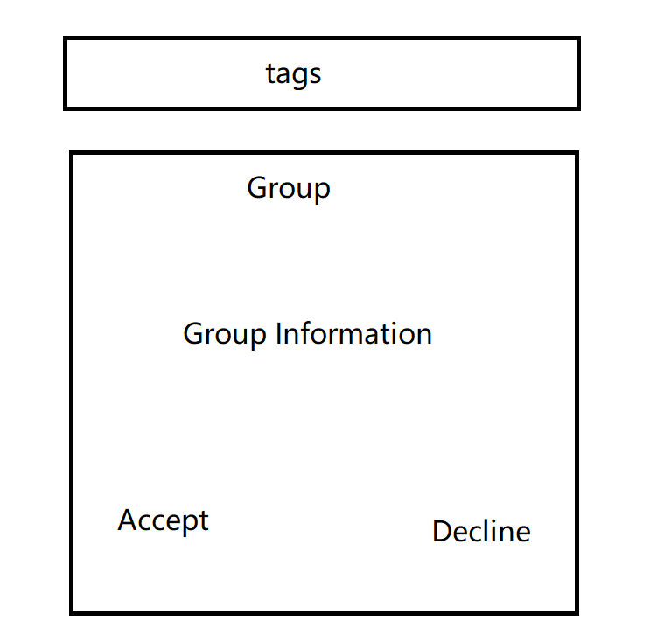
- Hengning:
  - More profile content
  - Email authentication
- Sicong:
  - Create event component
  - Delete group
  - Invite user
  - Utf-8
  - Leave group delay issue
  - User name refresh
3/5/2021
- Hengning:
  - Get other users’ profile (API ONLY)
  - Add column: group, includes event time, name, tag
- Ge:
  - Server deployment
- Sicong:
  - Create event component
- Lujie:
  - Update profile page layout
  - Edit color scheme

2021.2.22

User avatars.

2021.2.15
What we have now:
- Google Cloud server
  - Node.js starter code (?)
- React+flask+redux framework
- MYSQL Server by Digital Ocean
  - username = doadmin
  - password = rtrjvssd4s8bpp14
  - host = grickly-nyu-do-user-8731753-0.b.db.ondigitalocean.com
  - port = 25060
  - database = defaultdb
  - sslmode = REQUIRED
  - IPs to add:
    - 104.154.236.1 (server)
    - 108.30.189.19 (Hengning)
    - 108.41.198.167(Ge）
    - 74.108.37.176 (lujie & sicong)
    - 66.108.224.65 (Kejian, currently unavailable)
    - 173.68.67.78 （Kejian, currently on apt wifi）
- Material UI framework
  - Don’t have bootstrap
  - Have trouble installing @material.ui/core
- Matching:
  - Database: mysql
  - Pool connection: Apache Druid
  - Note[Kejian]:
    - Not a real-time matching problem.
    - A single waiting room?
    - Group matching by events.
    - Match by keywords?
Local deployment ok!

By 2021.2.18
TODO[hengning]: Write/Run queries on Mysql.
TODO[sicong]: API
TODO[lujie]: README update
TODO[lujie]: Create all frontend components
TODO[ge]: Google Cloud Console deployment
TODO[kejian]: GC deployment; more matching formulation

To connect to the server:
- You need to install GCloud Commandline, google it up
- #gcloud init, login with your nyu email
- # gcloud compute ssh grickly_grickly@grickly, try saving the ssh key in your cache
- Screen -r to pull up the backend, ctrl + c to interrupt, when you are done, ctrl + a, d, to back
- Remember to disconnect

Database schema
https://dbdiagram.io/d/6023f35b80d742080a3a0221

